Sunset Ridge Beginning Hawk Band
Handbook 2013-2014

Dear Band Parents and Students,

Welcome to a new school year and a new band season. I am so excited to have all of you in band and cannot wait to have an excellent year together. Beginning Band classes (5th Grade Band) will begin the week of August 26. Schedules will be handed out as soon as they are available. During this school year, we will work together to further your musical development. After all, choosing to develop these skills is proven to yield better grades, higher test scores, better math comprehension, and fosters a sense of teamwork.

As I am new to Sunset Ridge, I'd like to tell you a little bit about myself. This is my fourth year in the Deer Valley Unified School District. I come to Sunset Ridge from Village Meadows as the music, band, and choir director. Prior to Village Meadows Elementary, I was split between Mountain Shadows and Bellair Elementaries as the general music and choir director. I am extremely excited to move into the band director position at Sunset Ridge, as my doctorate is in instrumental performance (oboe specifically). During the fall season, I will be on staff with the Boulder Creek High School Marching Band as the woodwind tech. I am looking forward to a fun year with many new experiences as we learn together.

The following is a handbook that holds information deemed important to the band program. We will go over these pages briefly in class, but it is important that both parent and student know the guidelines. The last page must be completed, signed, detached, and returned by_______________. This will be the first graded assignment in band! Please keep the rest of the handbook for your personal reference. A copy will also be made available on our band website: www.ssrhawkbands.weebly.com. This website will be a great resource as the year progresses. On our site, you can find calendars, interactive websites, handouts/important materials, AZ State Standards, tax credit information, and so much more!

We will be holding an instrument rental night, hosted by Allegro Music, on Tuesday, August 20 beginning at 5:30pm. We will begin in the band room with a short informational/meet the teacher meeting. If you have any questions, please e-mail me at caryn.kunz@dvusd.org.

Looking forward to a fabulous year,
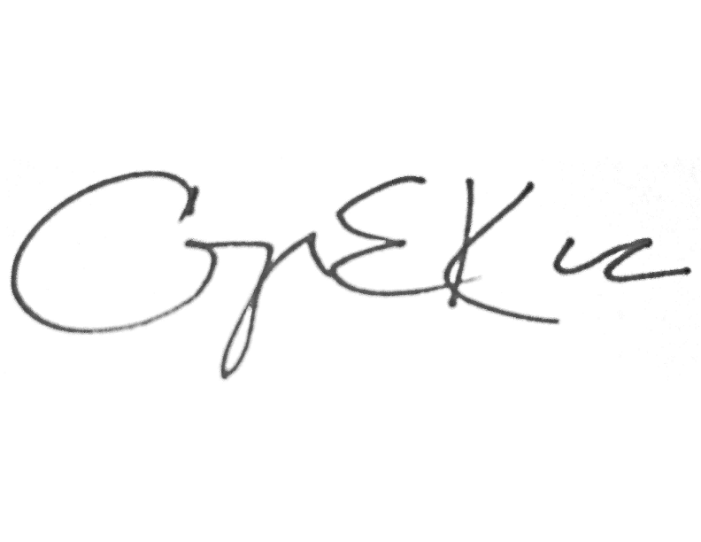

Dr. Caryn Kunz
Director of Bands
Sunset Ridge School
caryn.kunz@dvusd.org
www.ssrhawkbands.weebly.com

Course Description
5th Grade (Beginning) Hawk Band:
This course is designed to introduce and begin instruction on an instrument of choice. The student will learn the basics and begin refinement of their beginning skills. Concepts covered include instrument care and handling, tone production, characteristic sound, posture, breathing, note recognition and production, and many more.

Expectations and Procedures
Enter the room quietly, set up quickly, begin individual warm-up. This process should not take more than 5 minutes! Check out the daily objective/goal upon entering.

Do’s: Do Not’s:
Respect all people and equipment in room Candy, Gum, Food, Drinks
Play your best all of the time (water bottles allowed)
Bring all materials to class Yell, shout, scream.
-Includes instrument, music, supplies, pencil, eraser, Touch items that are not yours
Spiral notebook specifically for band. Allow others to touch your instrument
Give 110%! Leave seat or room without permission
Have a positive attitude Wear hats inside the building
Label everything with name
Practice (the more, the better!)

Consequences:
Praise Warning
Recognition Detention
Referral or more…

Attendance and Performances
Attendance is required at ALL performances and scheduled rehearsals (calendar available online). Concerts are an essential part of the band learning process. These performances highlight what has been learned in the classroom. As a result, attendance is required. If a student cannot make a performance, I must have written confirmation from a parent/guardian PRIOR to the event. Excused absences include: personal illness, family emergency. Students who miss a performance or scheduled rehearsal will be assigned an essay of 2-3 pages in length on a given topic and will present their findings to the class. Topics could include instrument history, performers on their instrument, or a selected composer. Essays are to be double spaced, font size 12.
**Band is a YEAR LONG commitment. Students are expected to remain in the program for the full school year.**

Performance Attire
Both ladies and gentleman will wear:
- White dress shirt - Pressed/ironed please! NO t-shirts, sleeveless, tank, or spaghetti strap tops allowed.
- Black dress pants/skirts - Skirts must be longer than knee length. NO jeans, cargo type pants.
- Black dress shoes - NO tennis shoes, sneakers, or flip flops
- Black socks/belt - Shirts should be tucked in and socks/belt should match (many ladies shirts are tailored to not be tucked in... use your best judgment)
- ALL performance attire must fit within the Sunset Ridge School dress code!
- Band T-shirt – I am looking into ordering band t-shirts for more casual performances, field trips, and/or spirit days. More information will come home should this be chosen.

Grades
Grades are given on a point system. This system is meant to encourage improvement and foster responsibility. Please check Power Schools for your child's most current grade. Allow up to 2 weeks for writing assignments to be inputted. Report cards are issued each quarter.

Grading Category | Approximate # of Points (subject to change)
Rehearsals | 40-50 points per quarter - Students must attend band, be prepared, and participate fully to get total points possible  2 points per class  2 points - Meets/Exceeds Objective  1 point - Approaches Objective  0 points - Falls Far Below Objective
Playing Exams | 15-20 points each (5-10 per quarter)
Assignments | 20 points per quarter (approx. 5 each)  Most are done in class.
Instrument Care | 10 points per quarter
Concert Attendance | 40 points per concert  Each student plays an important role in a performance. One missing student can detract from a performance for all

Failing Grades
If a student maintains a failing grade for at least 2 consecutive grading periods (progress report or report card), it will be recommended the student be dropped from the band program. Given the effort, all students should be able to receive a passing grade.

Extra Credit/Make-Up Work/Retakes
Extra credit may be earned (up to 15 points per quarter) through the following activities:
- Private Lesson Study - 10 points for weekly lessons. Form made available and must be signed by the private lesson teacher 2 weeks prior to the end of a grading quarter.
- Attend Outside Concert - 5 points each. Prompt found on our band website. Student must write 1-2 page reflection of a concert they attended (instrumental only).
- Participation in Extra Music Activity - 5 points each. This includes other instrumental ensembles and performances outside of the Sunset Ridge community. These experiences are extremely rewarding and worthy of extra points.
Make-up work
- This is the student's responsibility to seek out missing assignments from the teacher. If the student does not obtain missed work, the assignment will be turned into a zero at the end of the quarter.
- Student has up until 2 weeks prior to the end of a grading quarter to return missed work due to an absence.
Retakes
- Any student that does not display mastery (grade of A-/E- or higher) and would like to retake a test, either written or playing, they must schedule a time with the teacher. During the fall quarter, I will be available most Tuesdays and Thursdays after school from 3:30-4:30 for scheduled retakes.

Instrument Rental/Repair
There are many companies in town from which you may rent your instrument. We will be having an instrument rental night hosted by Allegro Music on Tuesday, August 20 at 5:30pm. We will begin in the band room at 5:30pm for a short meet the teacher/curriculum introduction. We will then move to the multi-purpose room for the actual rental presentation, which begins at 6pm. The evening is for your convenience. You may rent from any of the following rental companies:
- Allegro Music - www.allegromusicaz.com - 8385 W Deer Valley Rd, Suite 106, Peoria, AZ 85382 - (623)215-2214
- Music & Arts - www.musicarts.com - 5350 W Bell Road Suite 132, Glendale, AZ 85308 - (602)504-0206
- Milano Music - www.milanomusic.com - 38 W Main St, Mesa, AZ 85201 - (480)827-1111
- Boogie Music - www.boogiemusic.com - 3562 W Cactus Rd, Phoenix, AZ 85029 - (602)978-6688

Proper instrument care and maintenance will keep repairs minimal. If your instrument does need repair and is a rental, please take it to the shop from which you rent. Many times you'll find they have an interim instrument that they will loan you during repairs. Check with your rental company! If your instrument is owned, check with Dr. Kunz to see if there is an extra school instrument that may be borrowed while yours is being fixed. Recommended repair shops:
- Allegro Music - www.allegromusicaz.com - 8385 W Deer Valley Rd, Suite 106, Peoria, AZ 85382 - (623)215-2214
- Plumb Perfect Repair - www.plumbperfectrepair.com - 14633 N 32nd Lane, Phoenix, AZ 85053 - (623)375-3920

A limited number of school instruments are available for free rental for student use. Many of these instruments are older, but still in working order. These instruments will be assigned on a "first come, first serve" basis, with priority given to the 5th/6th grade band students. As an advanced 7th/8th grade band member, it is asked that rental from a music store is considered for a higher-level instrument that has a repair guarantee. To request a school instrument for rental:
- Complete and return an instrument request form explaining the reason(s) for this request.
- Parent completes and returns the DVUSD Instrument Rental Form.
- Student/parent must purchase and bring/show all necessary instrument care supplies with them to class before instrument will be sent home with student (i.e. swabs, cork grease)
- Student must demonstrate proper care for the instrument at all times. Any repair needed due to student negligence WILL be charged to the student and could lower their grade.
- Student must take the instrument home for practice and show improvement and effort.
Using a school instrument for free is a great privilege. Any student that does not show the responsibility and guidelines listed above runs the risk of losing school rental privileges. Nothing will be done without a phone call home or conference first.

Schedules
Schedules are in the process of being completed. The bands will start rehearsing on the following days/weeks:
- 5th Grade Beginning Hawk Band - Begins the week of August 26. Rental night will be held August 20. Students are expected to attend class with or without instruments and are expected to have materials by the end of their first week of instruction. We will go over procedures and instrument care during the first week, so instruments are not necessary to attend class. Students will have schedules handed out no later than Friday, August 23.
  - Students are responsible for knowing when their band time is. This is a pull out class and I will not be gathering the students. They are responsible for watching the clock and leaving their classroom appropriately so as to be on time for band.
  - Unexcused absences will be marked as a zero. I will be available one time a week for make-up time (either scheduled during the day or before/after school - TBD)

Contact
I am at Sunset Ridge daily. The best, and fastest, way to reach me is through e-mail: caryn.kunz@dvusd.org. I am happy schedule any meetings, if necessary. I will be communicating with parents predominantly through e-mails and our website as the year progresses. Do not hesitate to contact me with any comments, concerns, or questions. I am here for you and your students.

Instrument Specific Supplies
Instrument | Materials Needed (also available online)
Flute | - Cleaning Rod and Soft Cloth
Oboe | - Cork Grease  - Cleaning Swab (silk)  - Small container for H2O to soak reeds  - 2 reeds - DO NOT purchase at music store. These must be ordered from an oboe specific vendor. I also specialize and can make these from time to time for students. Range in price from $15-22
Clarinet/Saxophones | - Cork Grease  - Cleaning Swab (silk preferred)  - 3 working reeds - strength 2 for beginners.  - Brands: Van Doran, Mitchell Laurie, Rico Royal (NO Rico in orange/tan box)  - Chipped/Cracked Reeds are unacceptable/ unplayable.  - Saxophones Only: Neck Strap
Trumpet  French Horn Euphonium/Baritone  Trombone  Tuba | - Tuning Slide Grease  - Mouthpiece brush  - Trumpet/Tuba/Baritone Only: Valve Oil  - French Horn Only: Rotary Valve Oil (different than trumpet valve oil)  - Trombone Only: Slide Oil/Cream
Percussion | - 1 pair xylophone/bell mallets  - 1 pair CONCERT snare drum sticks (2B)  - Practice Pad for home practice
ALL | - Traditions of Excellence Book 1 (red cover)  - Folding wire music stand (optional)

Complete and return ONLY this page! To be returned to Dr. Kunz by_____________.
Contact Information

Name of Student:___________________________________ Grade/Instrument:__________________

Name(s) of Parent/Guardian(s):_______________________________________________________________

Home Phone:____________________________________ Cell Phone:_________________________

E-mail(s):___________________________________________________________________________________

Additional Ways of Contact (secondary e-mail/work phone):____________________________________

- - - - - - - - - - - - - - - - - - - - - - - - - - - - - - - - - - - - - - - - - - - - -

Photo/Internet Waiver

Photos and videos are periodically taken at concerts and events throughout the year. Only with your permission will pictures and/or videos be shared on our school or band webpage. I will not post full names with any photo or video (typically I do not use names at all). This is at your discretion. If you DO NOT want your child's photo to be used in any way, please indicate by writing the following sentence on the line provided and then sign your name:

"I do not want photographs of my child to be featured on the Sunset Ridge School /Band websites."

_____________________________________________________________________________________________

Signed:____________________________________

- - - - - - - - - - - - - - - - - - - - - - - - - - - - - - - - - - - - - - - - - - - - -

Student/Parent Agreement

I, (student's name printed)_______________________________________, have read and fully understand the band handbook. I agree to follow all rules and guidelines.

_____________________________________
Student Signature

I have read the band handbook with my child and will do my best to encourage and support my child in their musical endeavors.

_____________________________________
Parent Signature

